How to Circulate Books:

Go to the dropdown list to make sure you are in the correct category (i.e. Books to check out or All Reserved to check in, if its due date has passed it will be in the All Overdue category and can be checked in) 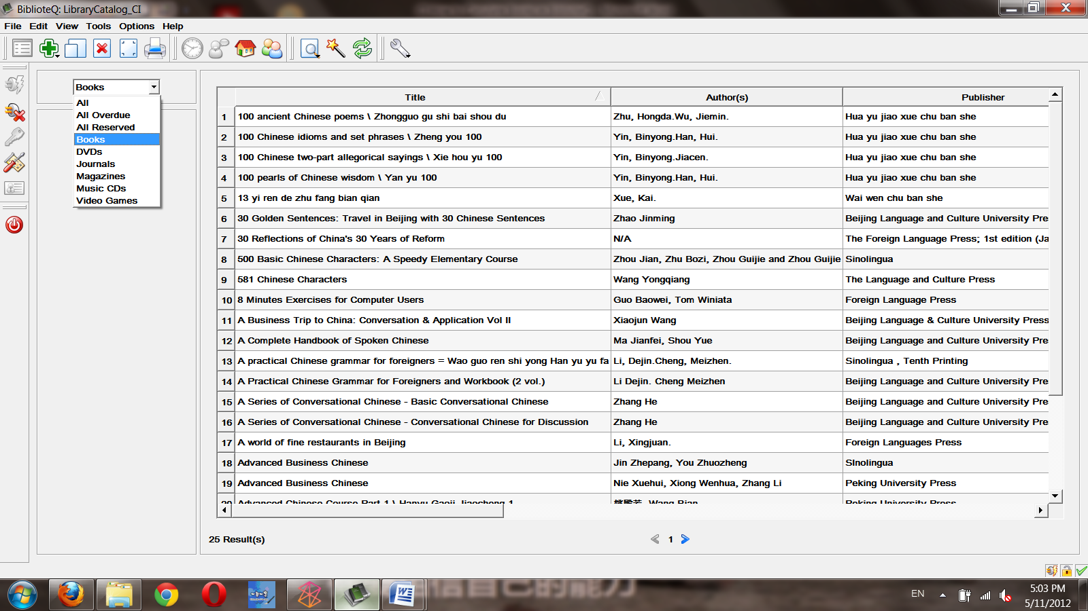

Go to the Magnifier icon to perform a search

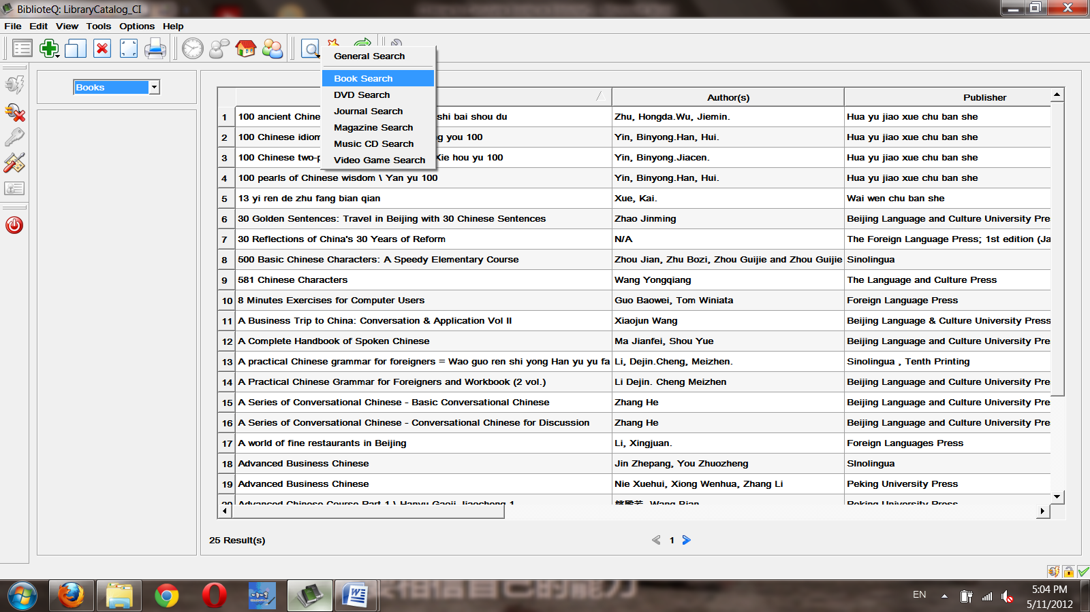

If you already know which book you would like, you can search by author, title, category, abstract, etc. Or if you have already chosen the book from the shelf, then you can search by ISBN to directly go to that entry. You can usually get the ISBN from the lower corner on the back cover of the book (a few volumes do not have an ISBN). You can either manually type it in or scan it with the barcode scanner. (Only the topmost row or the bottom left row are the numbers you need.)

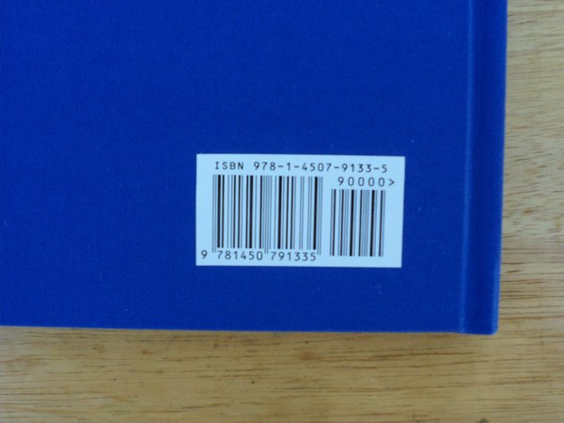

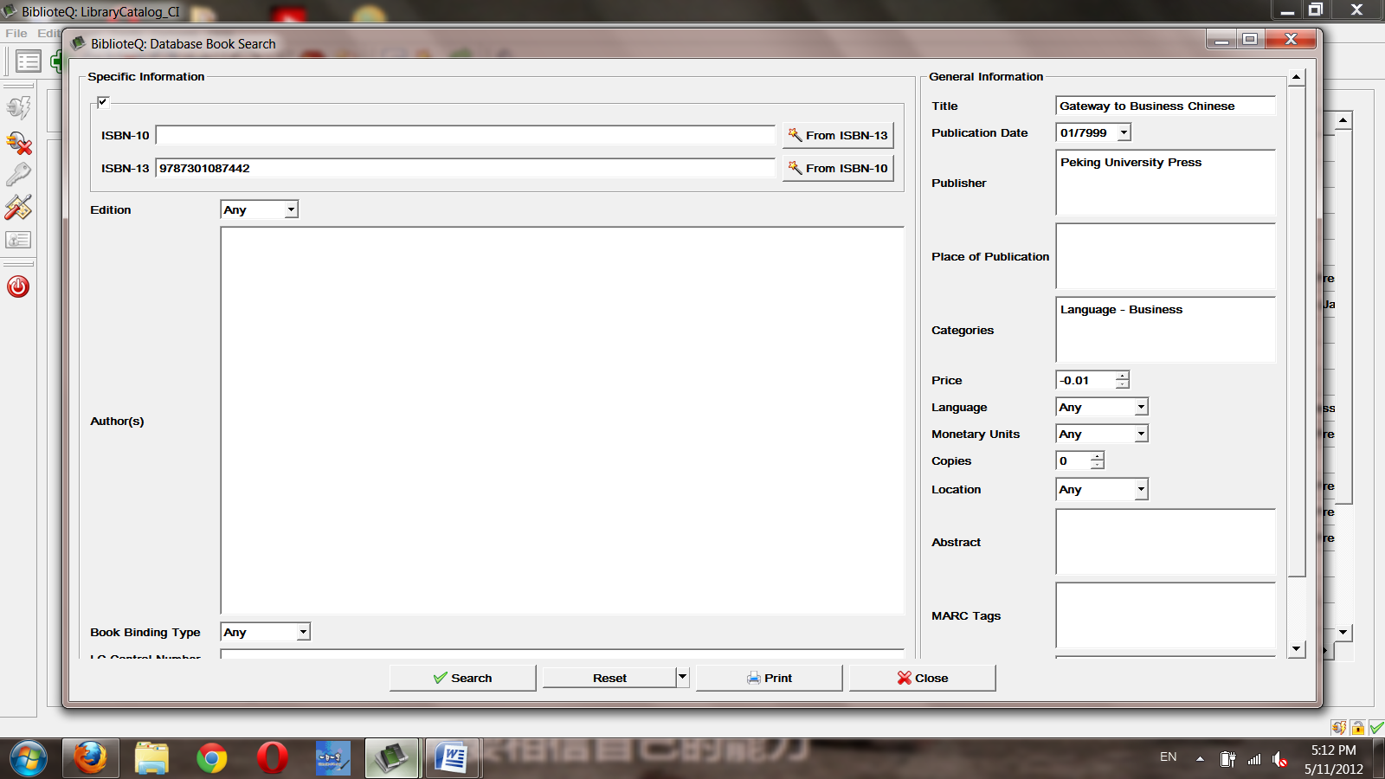

Now click “Search”. Click on the entry you want once to highlight it. Now click the “Display Members Browser” icon. 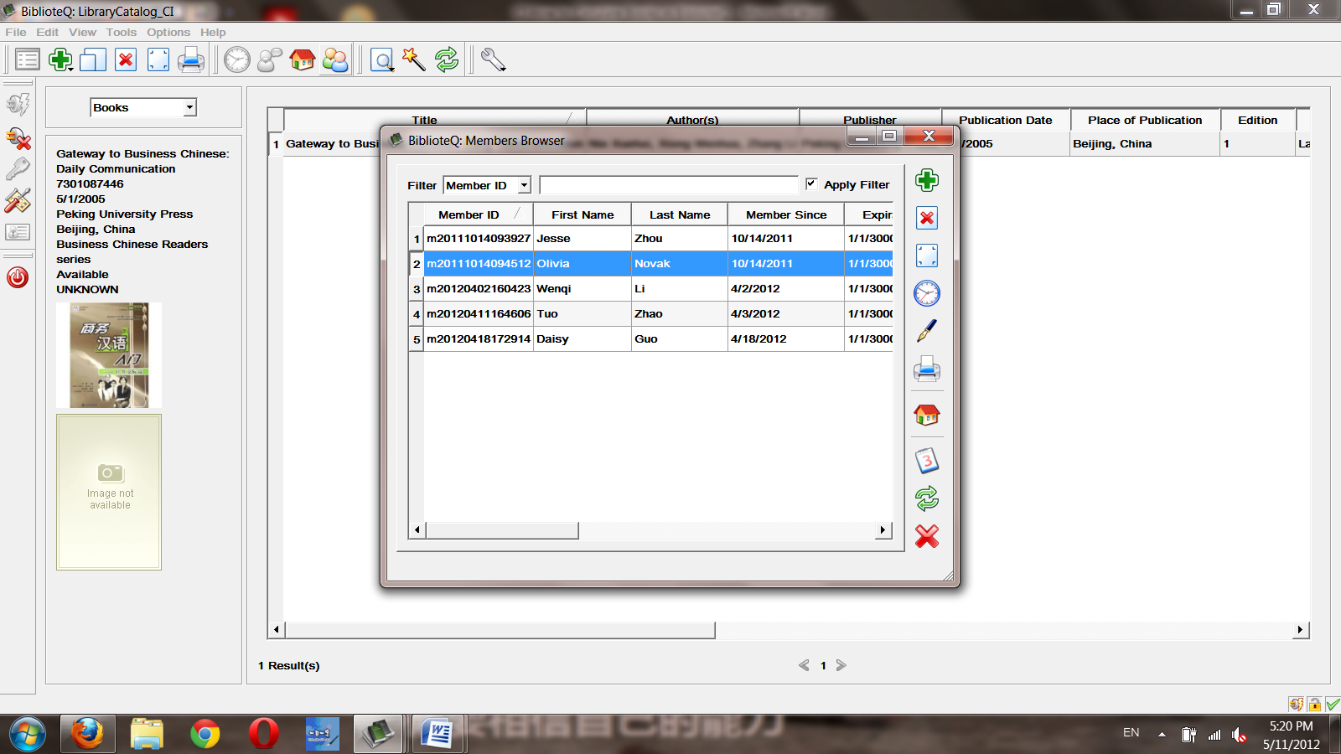

Select the member that wants to check out. Now select the home icon “Reserve Selected Item”. If a book has multiple copies, select the copy you are holding (the inner barcode and spine tag will indicate which number copy it is.)

Now you can adjust the due date if you like, it will automatically be set to the next day.

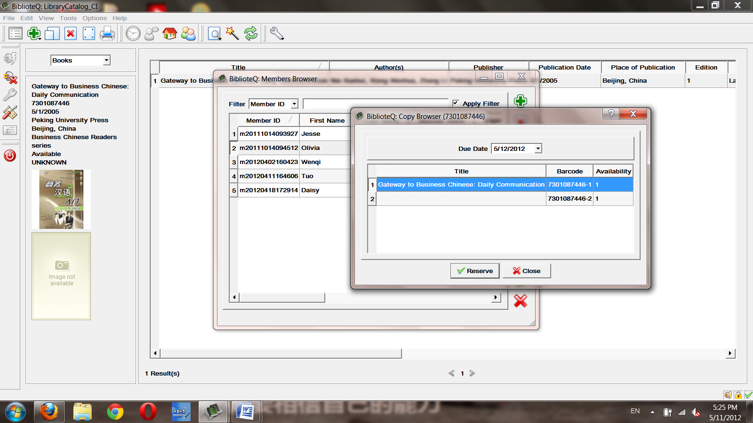

Click “Reserve”, and you’re done. It’s good to send a reminder email when due dates are near to the member’s contact email. Due dates can be viewed either by using “All Reserved” in the dropdown list or by member by selecting the members name and clicking the “List Selected Member’s Reserved Items”.

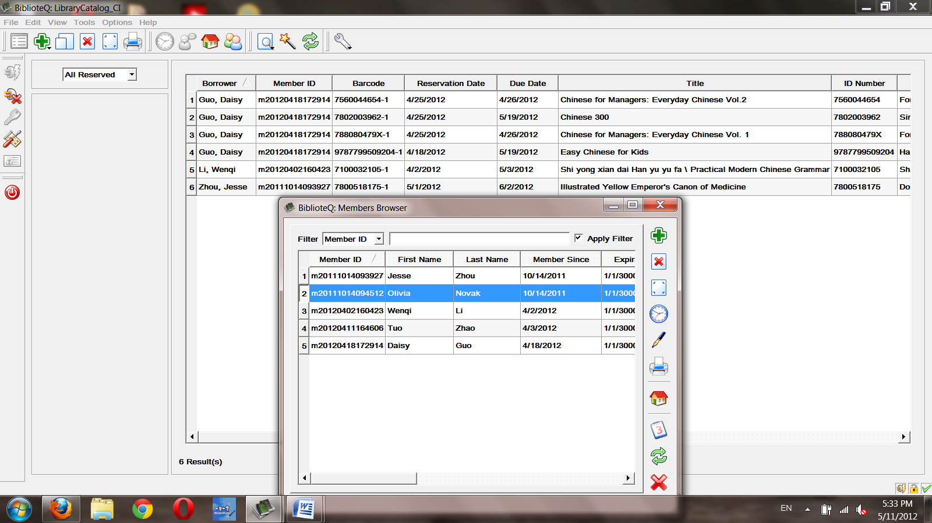

You can check in books the same way, finding all reserved or searching the book itself. Double-click on the book you want to check in and go down and right to the button that says “Reservation Status”. 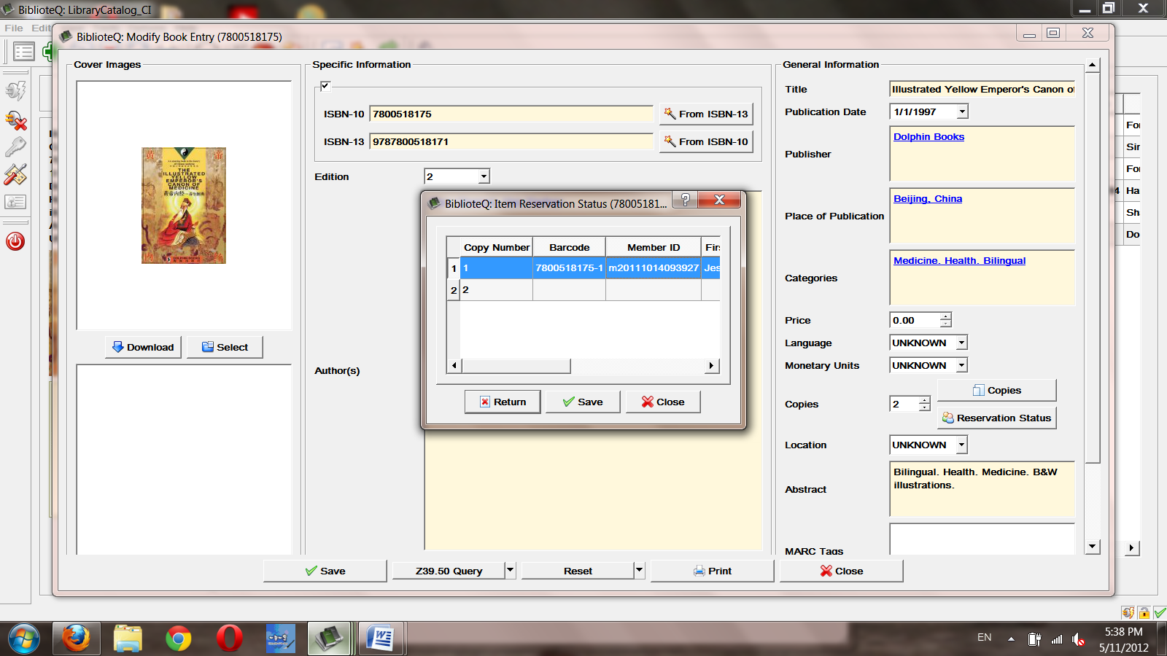

Select “Return” and “Yes”. The book is now checked in.